Banking

Manual

Version 1.0.2

1. **Login Module**

Please enter the username and password and click on submit button to login. The below are credentials username-> [rahulkajabe@gmail.com](mailto:rahulkajabe@gmail.com) and password is 123456

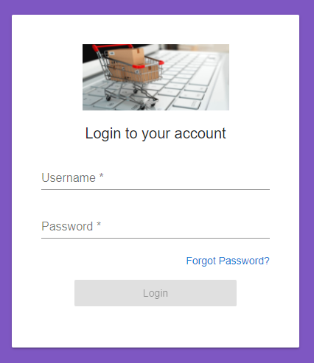

On invalid username and password error message will be appeared on screen.

To reset the password, click on forgot password? Link.

Enter the valid email address then link will sent to your registered mail id.

On successful login, Home screen will be appeared on screen below.

1. **Dashboard Module**

Below is the dashboard for Banking module.

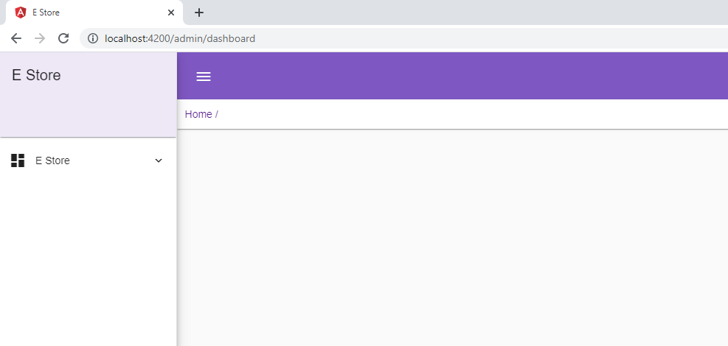

1. **Account -**

Please select the account and select the account from menu list.

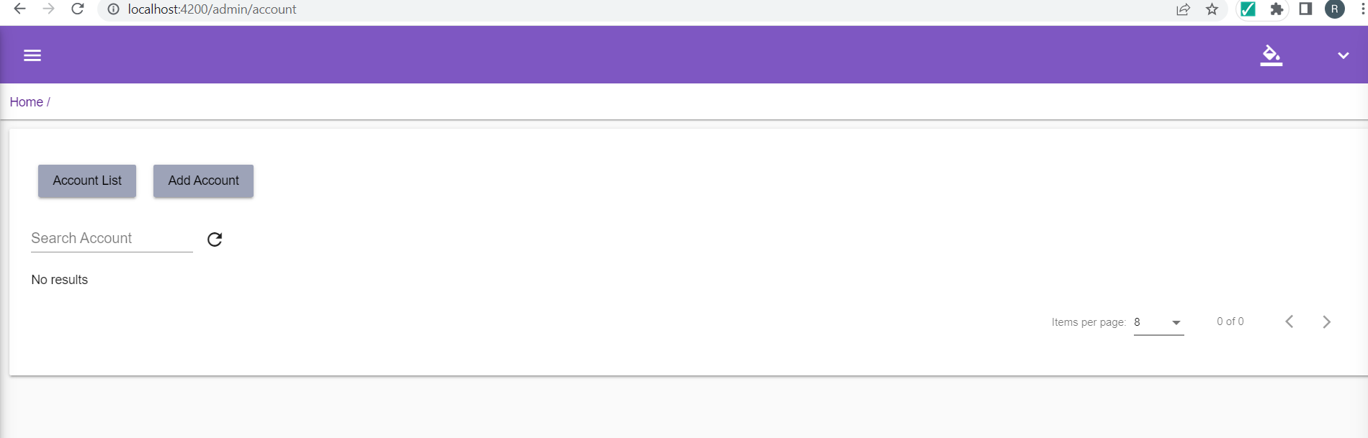

Then account page will be displayed on screen, click on Add Account button to add the account into system.

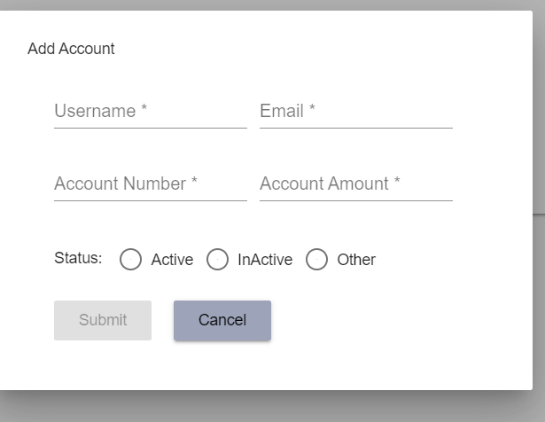

For update the Account, go to Account home page and click on edit button then window will be displayed on screen.